Ethan Allen Oak Bed

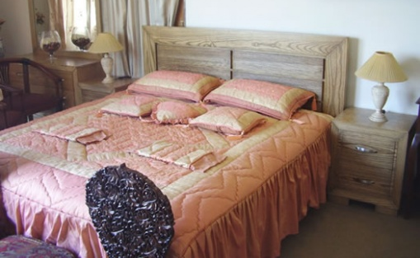

|  |
| --- |
| **DESCRIPTION** |
| Ethan Allen introduces a bed which made completely from oak. This bed is guaranteed to create the perfect look in any house. The rich wood makes you feel very important it gives you royalty at affordable rates. Oak is one of the strongest woods in the world it is designed to create Comfortable strong beds with flat spring mattress so that it does not lose its elasticity and stay together in place. |

|  |  |  |
| --- | --- | --- |
| **Price** | **1500$** | |
| **Dimensions** | **H** x **W** x **L** | **34in x 50in x 73in** |
| **Features** | **Springs used in mattress helps the mattress to adjust according to the weight of the body so that it doesn’t lose its elasticity.** | |
| **Finished** | **Natural Oak** | |
| **Available in** | **Dark and Light Brown** | |